Bhargavi Madhunala

Homework 4

Artificial Intelligence

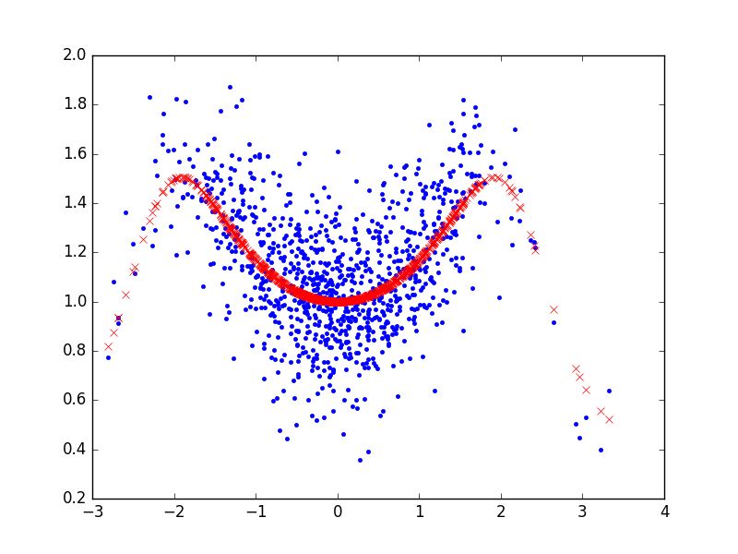

Problem 1 (a) : In this problem I just changed (x, y, ytrue = genDataSet (100)) to (x, y, ytrue = genDataSet (1000)). After executing I got this output graph.

Problem 1 (b): For this problem the best values of Eout [0.33037785041340262, 0.22163234331278633, 0.2216149760376227] by using 10- fold CV. At 1, 255, and 253 they are located.

Problem 1(c): For this problem the value for cv Eout will be 0.33037785041340262. Depending on the dataset the value changes.

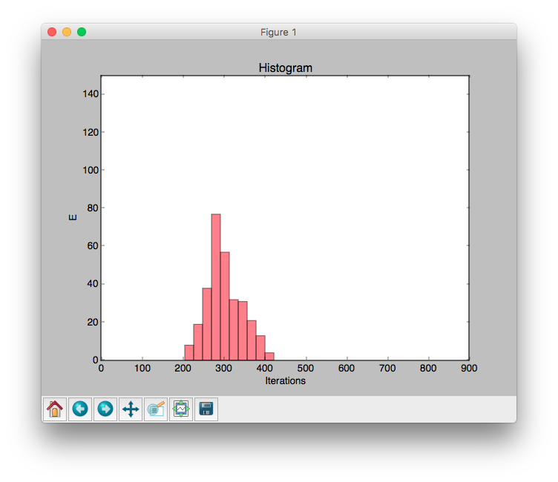

Problem 2. For the problem 2 after plotting the histogram I got this output graph.